Student Name | Application | Covid Card | Compliance & Privacy | TB Waiver | Confidentiality& permission | TB Test #1 | TB Test #2 | HIPAA Quiz | BBP Quiz | Hand Hygiene Quiz
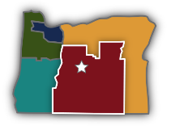
Health Occupations Compliance Needs
Teacher Checklist
Key:
Blue Rows- all part of the application process, access from CEAHEC website (www.cascadeseast.org)
Gold Rows- Paper copy of student’s TB Test Results
Green Rows- Required learning module quizzes (need a passing score of at least 8/10 or retake)

